Let us try to fix the errors in this sample app for a toy store.   
First lets walkthrough the ideal behavior of this app   
Several toys are stored in a local database.   
As soon as we launch the app we should see the list of all the toys available.   
  
  
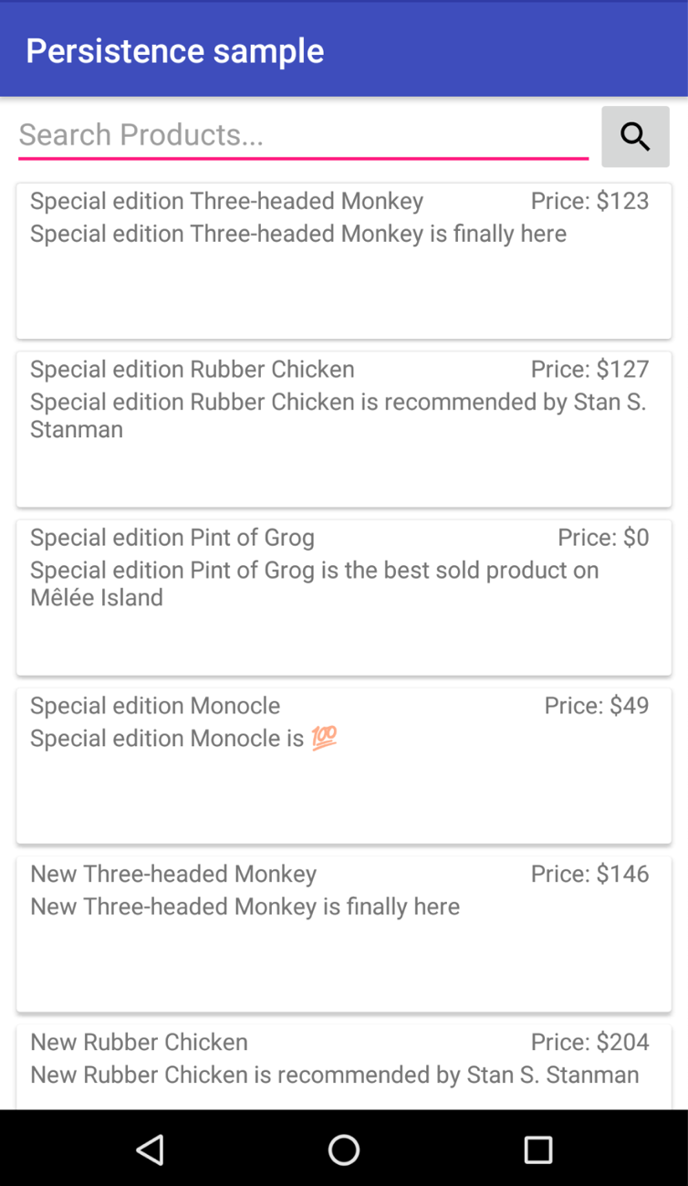  
  
You could search for a toy, for example: monocle, and the see the different types of `monocle`   
available in the database.  
  
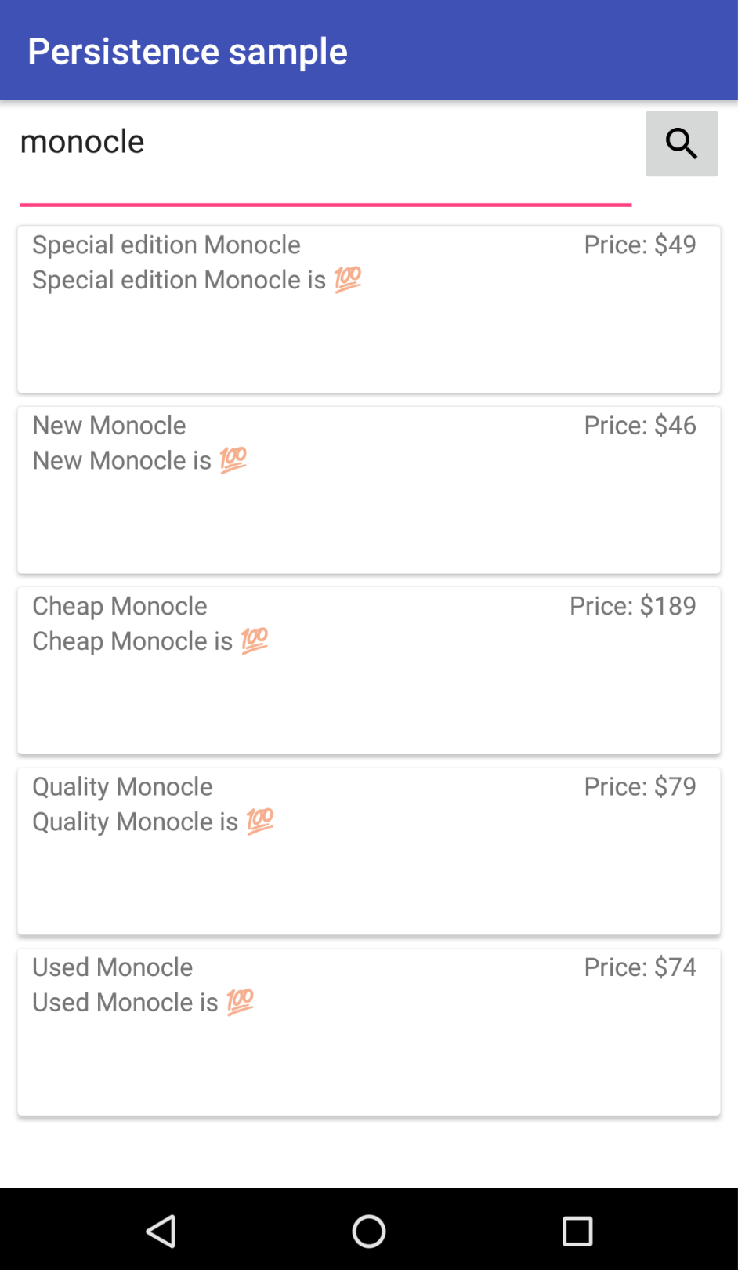  
  
 Clicking on the item shows the comments for that item.

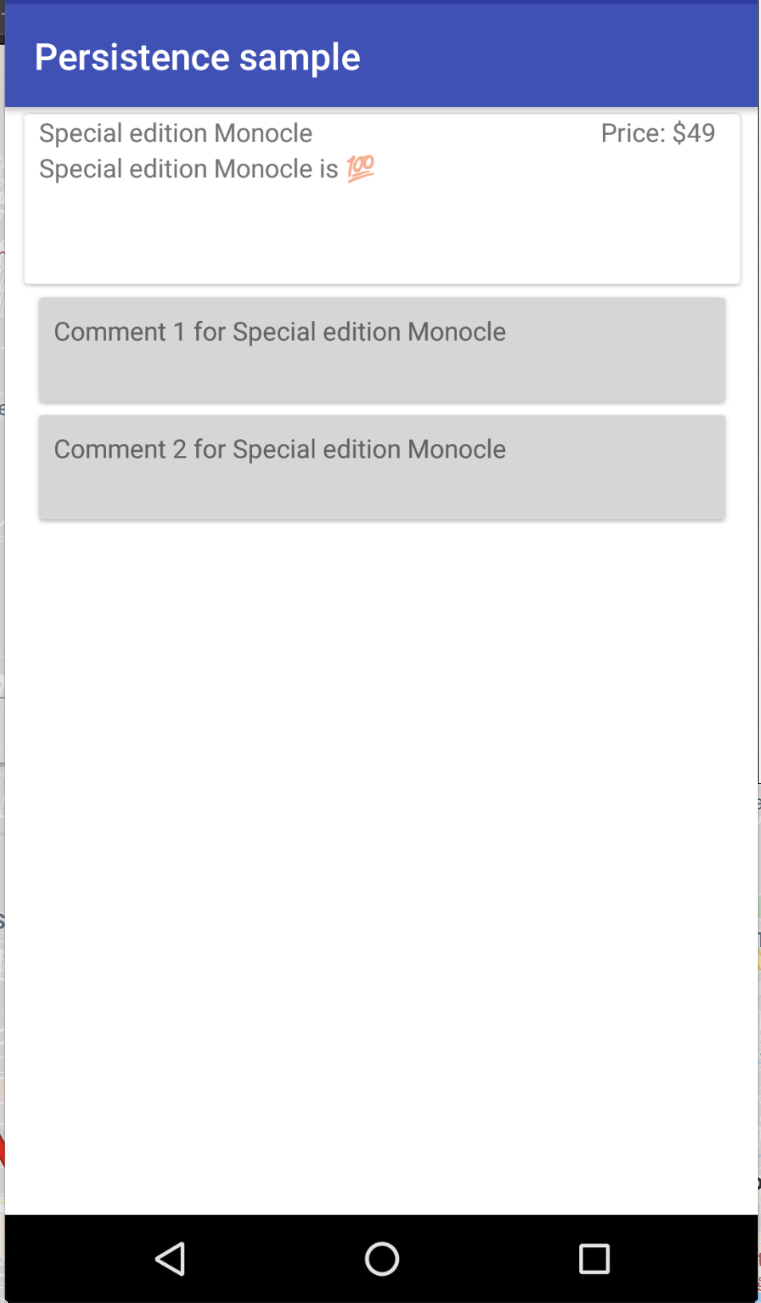

Now let look at the bugs that were introduced for this test.

1) As soon as we launch the app, the home page is stuck in the loading state.   
It should show the list of all the available products in the database.

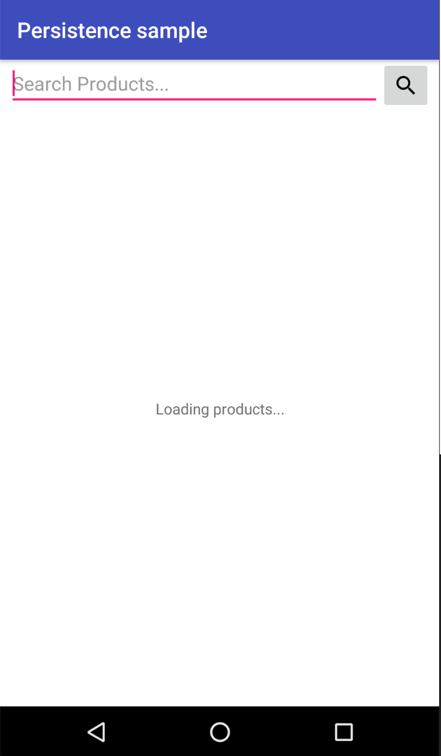

2. After searching for a product, for example monocle, it shows the same product several times instead of showing different types of monocle

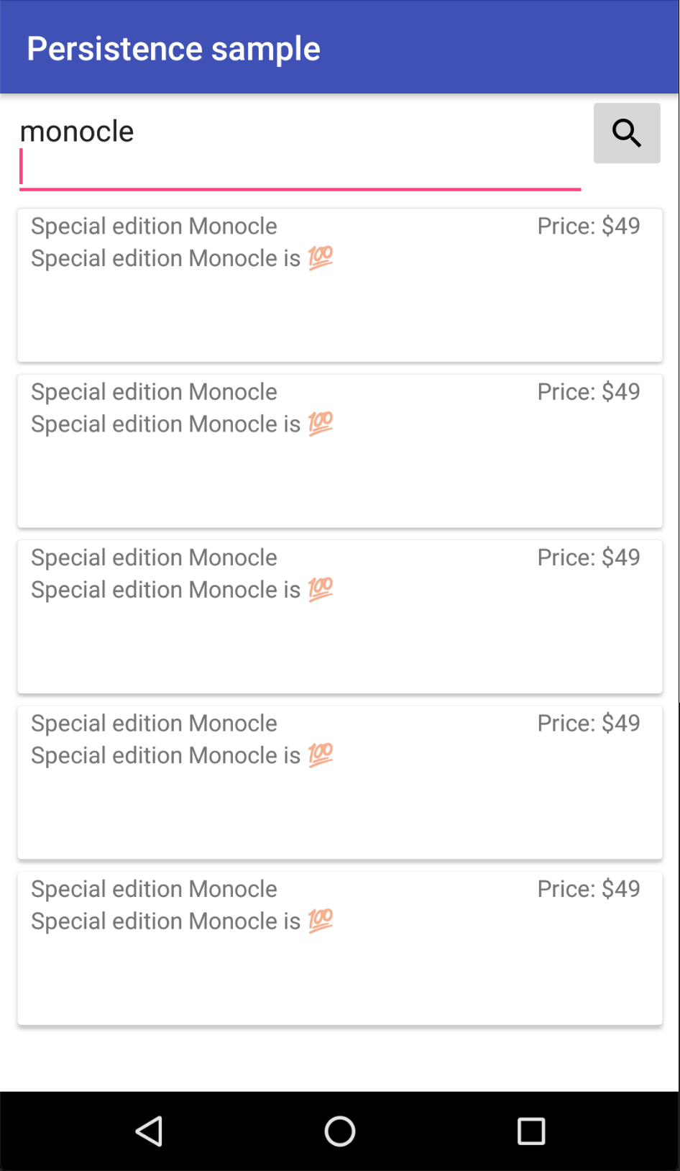

3. After clicking on the product, the comments and the contents are missing  
  
